A Project Report

On

Flappy Bird

Submitted in partial fulfillment of

the requirement of PROJECT-II

SUBJECT (BIT 156 CO)

of

Bachelors Of Information Technology

**Submitted to**



**Purbanchal University**

**Biratnagar, Nepal**

**Submitted By**

Bodhi Manandhar(322823)

Sambodhi Manandhar(322838)

Sandip Khadka(322839)

**KANTIPUR CITY COLLEGE**

Putalisadak, Kathmandu

May, 2023

A Project Report

on

Flappy Bird

Submitted in partial fulfillment of the requirement of PROJECT-II

SUBJECT (BIT 156 CO)

of

Bachelors Of Information Technology

**Submitted to**



**Purbanchal University**

**Biratnagar, Nepal**

**Submitted By**

Bodhi Manandhar(322823)

Sambodhi Manandhar(322838)

Sandip Khadka(322839)

**Project Supervisor**

Rubim Shrestha

Assistant Professor

**KANTIPUR CITY COLLEGE**

Putalisadak, Kathmandu

May, 2023

Table of Contents

Abstract ii

Acknowledgement iii

Preface iv

Declaration v

Supervisor's Approval vi

CERTIFICATE FROM DEPARTMENT vii

Chapter 1: Introduction 1

1.1 Background 1

1.2 Motivation 1

1.3 Objectives 1

1.4 Features 2

1.5 Scope and Limitation 2

1.6 Organization of the document 2

Chapter 2: Literature Overview 3

Chapter 3: System Design 4

3.1 Algorithm 4

3.2 Flowchart 5

3.3 Tools and Techniques 6

3.4 Function Used 7

3.5 Testing and Debugging 8

Chapter 4: Methodology and Schedule 9

4.1 Schedule 9

4.2 Assignment of Roles and Responsibilities 11

4.3 Gannt Chart 12

Conclusion 13

Reference 14

Screenshots 15

**List of tables and figures**

Figure 1: Flowchart 5

Table 1: Laptop Specification 6

Table 2: Function Table 7

Table 3: Testing and Debugging 8

Table 4: Roles and Responsibility 11

Table 5: Gannt Chart 12

# Abstract

This project aims to develop a Flappy bird game using C++ as a programming language. The game will provide a nostalgic and entertaining experience. It will allow the players to entertain themselves with a 2-d arcade type game. It will provide different stages for the player to immerse themselves into along with score count and changing pipe length. The movement of the bird is controlled through the series of the pipe. This project was possible by including knowledge from text and other simple graphics game. We took inspiration from various source materials and took our own approach to our project.

# Acknowledgement

We would like to thank the IT and BCA department for the wonderful opportunity to showcase our skill and widen our knowledge. Special thanks to our project supervisor and Mr. Rubim Shrestha sir for his insight and assistance in the project. Also, we would like to show appreciation to Mr. Saroj Pandey, Hod of department of BIT and Computer Applications to give us the opportunity to improve our skills in object-oriented programming.

# Preface

The venture points to reproduce the nostalgic feeling of the classic amusement. The project is decently straight forward and simple to play and can give excitement for the players. Flappy bird was well known because it was simple and fun game to play. We are going to attempt to form our adaptation of the amusement and progress the repetitive topic of the amusement.

# Declaration

We declare that this project report titled Flappy Bird submitted in partial fulfillment of the BIT is a record of original work carried out by us under the supervision of Mr. Rubim Shrestha and has not formed the basis for the award of any other degree or diploma, in this or any other Institution or University. In keeping with the ethical practice in reporting scientific information, due acknowledgements have been made wherever the findings of others have been cited.

Bodhi Manandhar (322823)

Sambodhi Manandhar (322838)

Sandip Khadka (322839)

Date:

# Supervisor's Approval

This is to certify that the major project entitled Flappy Bird undertaken and demonstrated by Bodhi Manandhar, Sambodhi Manandhar and Sandip Khadka has been successfully completed under my supervision as a partial fulfillment of the requirements for the degree of BIT, 2nd semester under Purbanchal University. I, henceforth, approve this project to be awarded the certificate by the concerned authority.

During supervision, I found students hardworking, skilled and ready to undertake any professional work related to this field in future.

-------------------------

Rubim Shrestha

Project Supervisor

Assistant Professor

Date:

# CERTIFICATE FROM DEPARTMENT

Following the Supervisor’s Approval and Examiners’ Acceptance, the project entitled “Flappy Bird” submitted by Bodhi Manandhar, Sambodhi Manandhar and Sandip Khadka as a partial fulfillment of the requirements for the degree of BIT, 2nd semester under Purbanchal University, has been officially awarded by this certificate.

I wish the students all the best for their future endeavors.

---------------------------

Saroj Pandey

HoD of IT and Computer Application

Date:

# Chapter 1: Introduction

Flappy bird project is based on a real-life mobile game which was popular in 2013. The project aims to recreate the nostalgic feeling of the classic game. The is fairly simple and easy to play and can provide entertainment for the players. Flappy bird was popular as it was a simple and a silly game. We will try to create our version of the game and improve the monotonous theme of the game.

## Background

Games are huge in today's world where mobile and pc games are just and if not popular than console games. Games are a great source of entertainment and is popular among all ages. But very few games get so popular that they leave an everlasting image in our head like angry bird, subway surfer etc. Such memorable game was flappy bird. Despite flappy bird's success it was fairly simple game with no change in theme and level no matter how long you play it for. The original game flappy bird was removed from App store and Google plays on February 10,2014 with cause being games over usage and addiction. The proposed game aims to bring back the bird so that it can leap forward and fly once again. The game will have more than one level(arena) as an improvement. The project will also have multiple stages for players to experience different arcade type styles. The game will be made using C++.

## Motivation

The motivations for the projects are:

* The original "Flappy Bird".
* Arcade games.
* To learn about the fundamentals of games.

## Objectives

The objectives of the project are as follow:

* To bring back a classic game.
* To entertain people.
* To popularize offline games.

## Features

Some of the features of the games are:

* The game will have more than one level(arena) as an improvement.
* It will have score counter.

## Scope and Limitation

The scope of the project is to implement the game for computers and provide entertainment. As the aim for the project is to entertain people it will be free to play. The project is also going to be single player and offline.

* It does not include ongoing maintenance and support of the system once it has been implemented.
* It does not have multiplayer option.
* It cannot be played with online features.
* It is only available for PC.

## Organization of the document

Chapter 1: It contains the general detail and introduction of the project. It contains the main objective of the project with features of the project. It also contains the scope and limitation of the project.

Chapter 2: It contains overview of the similar projects and original flappy bird.

Chapter 3: It contains algorithm and flowchart of the project.

Chapter 4: It contains schedule, roles and assignments and expected outcome of the project.

# Chapter 2: Literature Overview

There are many games like flappy bird which share a similar mechanics. However, we took the approach to analyze the attempt to recreate the original game. It is an offline game obstacle clearing game. The game is a side scroller format where the player controls the movement of the bird to clear obstacles.

The game is very monotonous in which the only thing to update is the height of gaps between the pipes and a score count that goes up with it. A player does not have any sense of accomplishment except the score. There is no arena or theme change.

Another game that we reviewed was snake game, in which a snake moves around the map eating coins/apples and gain points along with adding size to the snake. The game ended when the snake collided with objects, map or itself. The game had similar moving mechanics and map which was a great example to study.

# Chapter 3: System Design

## 3.1 Algorithm

Step 1: START

Step 2: Initialize and setup objects.

Step 3: Initiate the start() function.

Step 4: Was the jump action performed or not?

If YES move the bird upward.

Step 5: Check for collision.

Check for collision with pipe and fall from map.

If Yes GOTO 7.

Step 6: Did the bird collect the egg?

If YES add +1 point.

If NO GOTO 4.

Step 7: Show game over and score.

Step 8: STOP

## 3.2 Flowchart

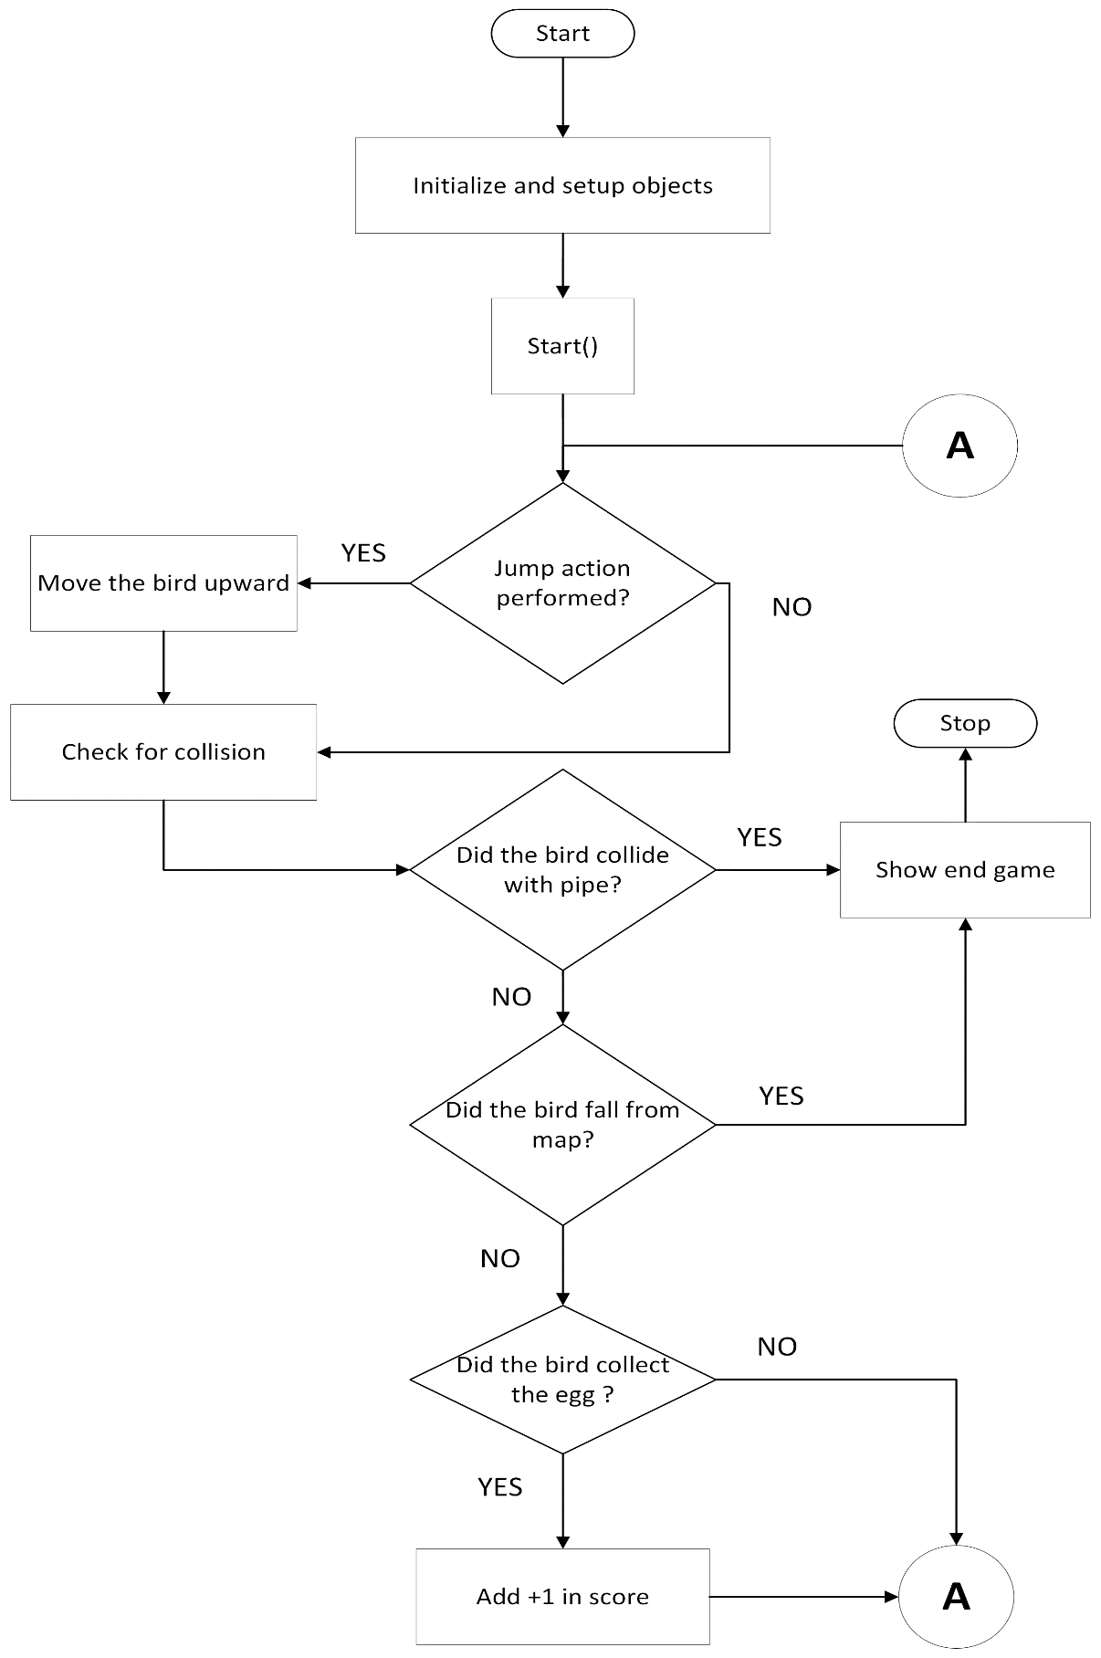

Figure 1: Flowchart

## 3.3 Tools and Techniques

The project was done in:

* IDE: DEV CPP
* Compiler: MinGw + Graphics.h

Tools used was a laptop.

Table 1: Laptop Specification

|  |  |
| --- | --- |
| OS Name | Microsoft Windows 10 pro |
| System manufacturer | Lenovo |
| Processor | Intel [i5-4200CPU@ 1.60GHz,2301](mailto:i5-4200CPU@1.60GHz,2301) Mhz |
| RAM | 4 GB |
| System type | x64-based PC |

## 3.4 Function Used

Table 2: Function Table

|  |  |  |
| --- | --- | --- |
| S.N. | Function Name | Use |
| 1. | circle() | Draws a circle with designated coordinates and radius |
| 2. | rectangle() | Draws a rectangle with designated points |
| 3. | floodellipse() | Fills the circle with specified fill style and color |
| 4. | floodfill() | Fills a designatted area with specified color and style |
| 5. | cleardevice() | Clears the screen |
| 6. | outtextxy() | Displays string through graphics |
| 7. | setcolor() | Sets color |
| 8. | settextstyle() | Sets font,size of the displayed string |

## 3.5 Testing and Debugging

Table 3: Testing and Debugging

|  |  |  |  |  |
| --- | --- | --- | --- | --- |
| S.N. | Test Objective | Expected Outcome | Actual Outcome | Remark |
| 1. | floodfill() for circle() to fill it with color. | Red fill circle | Red fill in background | Fail |
| 2. | fillellipse() for circle() to fill it with color. | Red fill circle | Red fill cirlce | Pass |
| 3. | Use of friend function to run all function | All function running simultaneously | Only first function running. | Fail |
| 4. | Use of a single function with buffer points for drawing all objects. | Smooth gameplay | Smooth gameplay | Pass |
| 5. | setactivepage(drawBuffer),  setvisualpage(displayBuffer) | Swap buffer to show image on the screen | Swap buffer to show image on the screen | Pass |
| 6. | Swap buffer and delay for the next frame | Smooth transition to next frame | Smooth transiton to next frame | Pass |

# **Chapter 4: Methodology and Schedule**

Flappy bird is a simple 2-d single view game with only purpose to dodge obstacles through the pipe. It will be developed using C++ programming language for the front-end interface as well as back end will be designed using C++.

It will be able to change level in reference to the score count on the screen and the speed of oncoming obstacles is adjusted by level. More the score increases the more speed will be greater too.

## 4.1 Schedule

**Week 1: Concept Submission**

Gather a simple idea for the project with expected plan for the project.

**Week 2: Research and Analysis**

Identify the requirements and use of header files.

Research the available tools and compilers.

Create a project plan.

Understand the limitation of our current level of knowledge.

**Week 2: System Design**

Design and develop the basic motion and mechanics of the game.

Test and debug the mechanics to ensure it is performing as expected.

**Week 2-9: Coding**

Start the basic outline of the code.

Develop the outline of the map and obstacles with simple graphics.

**Week 6-12: Debugging and Testing**

Test the program for semantic and syntax error.

Correct according to the expected outcome.

**Week 2-12: Documentation**

Basic documentation will begin from the beginning.

Progress will be added simultaneously according to the level of completion.

## 4.2 Assignment of Roles and Responsibilities

Table 4: Roles and Responsibility

|  |  |
| --- | --- |
| Member Name | Roles and Responsibility |
| Bodhi Manandhar | Bird and egg algorithm / Chapter 1 |
| Sambodhi Manandhar | Score algorithm / Chapter 3,4 |
| Sandip Khadka | Pipe algorithm and score count / Chapter 2 |

## 4.3 Gannt Chart

Table 5: Gannt Chart

|  |  |  |  |  |  |  |  |  |  |  |  |  |  |  |
| --- | --- | --- | --- | --- | --- | --- | --- | --- | --- | --- | --- | --- | --- | --- |
| **S.N.** | **Tasks** | **Duration** | **1**  **(Feb 26)** | **2** | **3** | **4** | **5** | **6** | **7** | **8** | **9** | **10** | **11** | **12**  **(May**  **14)** |
| 1 | Concept Submission | 1 week |  |  |  |  |  |  |  |  |  |  |  |  |
| 2 | Research and Analysis | 1 week |  |  |  |  |  |  |  |  |  |  |  |  |
| 3 | System Design | 1 week |  |  |  |  |  |  |  |  |  |  |  |  |
| 4 | Coding | 8 weeks |  |  |  |  |  |  |  |  |  |  |  |  |
| 5 | Debugging and Testing | 7 weeks |  |  |  |  |  |  |  |  |  |  |  |  |
| 6 | Documentation | 11 weeks |  |  |  |  |  |  |  |  |  |  |  |  |

# Conclusion

The project aims to recreate experience of the classic game with an approach to learn and use our knowledge in a practical way. The project was able to teach us the different game development logics and game development terminologies. The project was a great experience and the whole idea of a playable game is still surreal.

* The project is built in C++ using graphics.h file extension.
* It does not include ongoing maintenance and support of the system once it has been implemented.

# Reference

https://gamespec.tech/how-to-add-graphics-in-dev-c/ (accessed may 12, 2023).

CodeGuide. *How to build a popular Flappy Bird game using C++.* january 2, 2023.

*Flappy bird.*

Seneque, Jean Noel. "game develoopment with raylib."

# Screenshots

